THE RELAY

1. What is a relay
It is an electromechanical device with two components: the coil and the contacts. The coil receives a small electric current at low voltage in the control circuit and moves the contacts that act as switches of higher current and voltage in the power circuit.

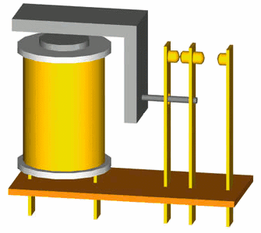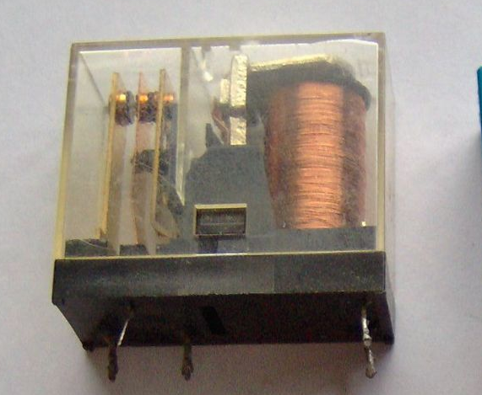
Scheme and photograph of a relay
(commons.wikimedia.org/wiki/File:Relay_principle_horizontal_new.gif
commons.wikimedia.org/wiki/File:Electronic_component_relays.jpg)

In this way, a small electric current is able to move high-power circuits.

2. Relay operation
The following schematic shows the circuit of a relay in operation.
The control circuit is on the left and consists of a 12 volt battery, a push button and the coil of the relay. When the push button is pressed, the current reaches the coil and activates the power contact (switch).
The power circuit consists of a relay contact, a 230 volt AC generator and a motor. When the contact closes, voltage is supplied to the motor and it starts up.
An advantage of this scheme is that the pushbutton has a human-safe voltage, separate from the high voltage of the motor, which is more suitable for supplying high power.

3. Relay with feedback
A relay has several contacts, some normally open and some normally closed. These contacts can be used to feedback the control circuit so that it remains operating once the relay has been activated. In the following diagram we can see a relay with run and stop operation. The run pushbutton activates the coil and, once activated, the two K1 contacts associated with the relay keep the coil energized and the motor running even if the run button is not pressed.
Licencia CC BY-SA 4.0 picuino.com
To stop the circuit, the stop pushbutton must be pressed. The coil will be de-energized and the two K1 contacts open, stopping the circuit.

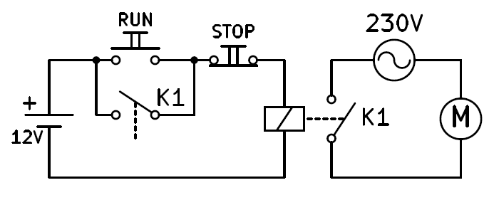

4. Oscillating relay
In this case the feedback will be done with a normally closed contact of the relay K1. When the push button S1 is pressed, current will flow through the coil, the coil will act by moving the contacts and the normally closed contact K1 will open. When this contact opens, current will stop flowing through the coil and the coil will stop acting so that contact K1 will close again allowing current to flow through the coil again.
The result will be an oscillation in which the relay will vibrate over and over again, opening and closing its contacts as fast as its design permits..

5. History of the relay
The relay was invented in 1835 and began to be used in telegraphy to amplify long distance signals. As the relay is capable of controlling a higher output power than the input power, it can be considered an amplifier that allowed to increase the quality of telegraph signals.
In 1941 Konrad Zuse built the first relay-based computer. The relays were later replaced by much faster vacuum valves. From the 1950s onwards, even faster and much more reliable transistors began to be used, which are still in use today.
Although relays are no longer used as the basis for computers, they are still frequently used today in automation to control motors and other high-power elements. For example, they are used in the home to drive elevators, water pumps or the light timer in the staircase.

6. Contactors
Contactors are special high power relays used to drive three-phase motors, i.e. they have three power supply lines.
In the following drawing you can see the schematic of a contactor feeding a three-phase motor. In this circuit you can appreciate the value of the relays to handle large powers and switch many circuits with a small low voltage signal.

EXERCISES

1. What is a relay and what is it used for?
2. Draw the schematic of a relay that turns on a 125V light bulb from a 24V push button.
3. Draw the schematic of a relay that turns on a 23 Ohm resistor fed at 220V with two pushbuttons, one for start and one for stop. Explain how the circuit works.
4. Draw the two states of an oscillating relay while pressing the pushbutton.
5. What uses has the relay had throughout history? What is it used for today?
6. What electronic components replaced the relay?
7. What is a contactor and why are they used?
8. Draw the schematic of a contactor that always operates a motor until a normally closed contact is pressed.

